Digital Learning Day Assignment: Complete the following problems. Show your work on a separate sheet that must be turned in the day that school resumes. Fill in your answers below. Email this page to Ms. Hill at portwoodf@fultonschools.org on the Digital Learning Day by the end of the day.
Super Bowl Sunday: who needs a game when there are snacks to be eaten?
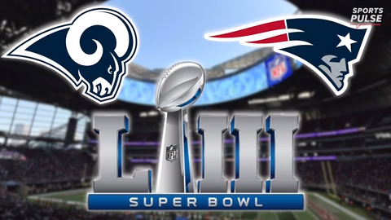
When it comes to food consumption, Super Bowl Sunday is second only to Thanksgiving.
"They smile when you hit the door, because hey, I have your food," said pizza deliveryman Richie Lorenzana.
- The average number of people at a Super Bowl party is 17. If the average pizza is cut into 8 slices and each person will eat 2 slices how many pizza’s should the host order?_________________ How many slices will be left over?______________________
At Ultimate California Pizza the Super Bowl is like a holiday. It's one of their busiest days of the year.
This weekend's business is expected to double compared to a typical Sunday. Many customers will call in their orders.
- If I call in an order for my pizzas at 4:00pm at what time can I expect the pizzas to be at my front door? It will take 20 minutes to cook the pies, and 30 minutes to deliver them. _______________________
"People are at home, and they want the food brought to them as a convenience. They like pizza and wings and things like comfort food, the stuff everybody likes. So our delivery is where our big sales increase comes from," says Bob Voss, manager.
Nearly 60% of takeout food ordered on Super Bowl Sunday is pizza.
- The three biggest pizza chains Papa John’s, Pizza Hut and Dominos expect to sell 3.2 million pies in total on Super Bowl Sunday.
  - If the average pizza costs $11.50 how much will Americans spend on pizza this day?________________
  - If the pies each have 8 slices how many slices of pie are there?_______________________
"Cause the game starts right around six o'clock, people order beforehand, eat beforehand, and then half time comes, and they'll order some more, and that's it for the night, and they're about full," said Lorenzana.
"It's just fun to have a busy day in the middle of winter," added Voss.
But pizza isn't the only popular item.
A whopping 14,500 tons of chips will be consumed on Super Bowl Sunday.
- 1 ton = 2,000 pounds. How many pounds of chips will Americans consume on Super Bowl Sunday?____________
  - Write this in scientific notation______________________________
- 1 pound= 16 oz. How many ounces of chips will American consume on Super Bowl Sunday?________________

